**Design principles & Patterns**

**Week 1**

**Exercise 1: Implementing the Singleton Pattern**

**Code:**

Logger.java

public class Logger {

private static Logger singleInstance;

private Logger() {

System.out.println("Logger initialized");

}

public static Logger getInstance() {

if (singleInstance == null) {

singleInstance = new Logger();

}

return singleInstance;

}

public void log(String message) {

System.out.println("[LOG]: " + message);

}

}

TestLogger.java

public class TestLogger {

public static void main(String[] args) {

Logger logger1 = Logger.getInstance();

logger1.log("First log message");

Logger logger2 = Logger.getInstance();

logger2.log("Second log message");

if (logger1 == logger2) {

System.out.println("Both logger1 and logger2 are the same instance.");

} else {

System.out.println("Different instances exist.");

}

}

}

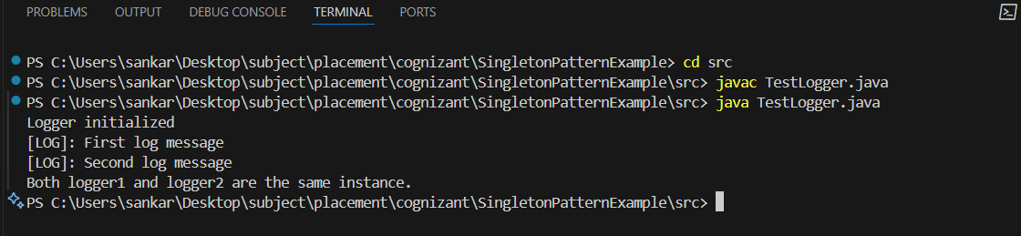

**Exercise 2: Implementing the Factory Method Pattern**

**Code:**

**Document.java (Interface)**

public interface Document {

void open();

}

**WordDocument.java**

public class WordDocument implements Document {

@Override

public void open() {

System.out.println("Opening Word Document...");

}

}

**PdfDocument.java**

public class PdfDocument implements Document {

@Override

public void open() {

System.out.println("Opening PDF Document...");

}

}

**ExcelDocument.java**

public class ExcelDocument implements Document {

@Override

public void open() {

System.out.println("Opening Excel Document...");

}

}

**DocumentFactory.java (Abstract Factory)**

public abstract class DocumentFactory {

public abstract Document createDocument();

}

**WordDocumentFactory.java**

public class WordDocumentFactory extends DocumentFactory {

@Override

public Document createDocument() {

return new WordDocument();

}

}

**PdfDocumentFactory.java**

public class PdfDocumentFactory extends DocumentFactory {

@Override

public Document createDocument() {

return new PdfDocument();

}

}

**ExcelDocumentFactory.java**

public class ExcelDocumentFactory extends DocumentFactory {

@Override

public Document createDocument() {

return new ExcelDocument();

}

}

**TestFactoryMethod.java**

public class TestFactoryMethod {

public static void main(String[] args) {

DocumentFactory wordFactory = new WordDocumentFactory();

Document word = wordFactory.createDocument();

word.open();

DocumentFactory pdfFactory = new PdfDocumentFactory();

Document pdf = pdfFactory.createDocument();

pdf.open();

DocumentFactory excelFactory = new ExcelDocumentFactory();

Document excel = excelFactory.createDocument();

excel.open();

}

}

**Output:**

